

Bangladesh University of Business and Technology (BUBT)
Faculty of Engineering & Applied Sciences (FEAS)
Department of Computer Science and Engineering (CSE)

COURSE TEACHER:
Name | : | Md. Ashiqur Rahman | Classroom Code: | :
Designation | : | Assistant Professor | Contact: | : | +8801621410068
Email | : | ashiqur@bubt.edu.bd | Specialization: | : | Medical Imaging, Computational Social Science, Interpretability

CLASS SCHEDULE:
Class Day | Class Hours | Room
Sunday | 02.45 pm – 04.00 pm | B2/906
Wednesday | 09.15 am – 10.30 am | B2/810

COUNSELING HOURS:
Day | Counseling Hours | Room
Sunday | 10.30 am – 11.45 am | B1/314
Tuesday | 10.30 am – 11.45 am | B1/314
Wednesday | 10.30 am – 11.45 am | B1/314

Course Type: Core Course
Credit Hours: 3.00
Prerequisite: N/A
Total Marks: 100
Program: B.Sc. Engg. in Computer Science and Engineering
Session: Fall 2024
Level-Term: L1-T2
Course Code: 0613103
Course Title: Discrete Mathematics
Credit Value: 3 3.00

Course Rationale | This course will provide students with the opportunity to develop logical thinking and its application to computer science. This course focuses precisely on computational problems and the use of mathematical operations such as sets, functions, relations, orders, sequences, etc. It also provides a basic knowledge of graph representation and tree operations. It emphasizes the importance of proving statements correctly. The subject enhances one’s ability to reason and present a coherent and mathematically accurate argument.
Course Objectives | Students will have the chance in this class to strengthen their logical thinking skills and learn how such skills might be used in the field of computer science. In this course, the emphasis is squarely placed on computational issues and the application of various mathematical operations, including sets, functions, relations, orders, sequences, and so on. In addition to this, a fundamental understanding of graph representation and tree operations is imparted. It places an emphasis on the significance of proving claims in the proper manner. The study of this topic improves one's capacity to reason and to provide an argument that is logically consistent and mathematically correct.
Course Outcomes (COs) | Upon completing this course, students will be able to:  CO1: Understand the fundamentals of discrete mathematics such as a logical relation in terms of predicates, quantifiers, and logical connectives.  CO2: Explain the basic principles of sets, functions, relations, recurrence, concepts of tree and graph and their various operations.  CO3: Apply proof techniques, number theory, counting principles for solving problem.  CO4: Analyze graphs, trees and their various properties for real life applications.
COs to POs  Mapping | CO PO1 PO2 PO3 PO4 PO5 PO6 PO7 PO8 PO9 PO10 PO11 PO12  CO1 √  CO2 √  CO3 √  CO4 √  CO PO Bloom’s Domain / Level Delivery Methods / Activities Assessment Tools  CO1 PO1 Cognitive/Understanding Class Lecture & Discussion Midterm  CO2 PO1 Cognitive/Understanding Class Lecture & Discussion Midterm & Final  CO3 PO2 Cognitive/Analyzing Class Lecture & Problem Solving Midterm & Final  CO4 PO3 Cognitive/Applying Problem Solving Midterm & Final

LECTURE PLAN (WEEKLY SCHEDULE)
Week | Selected Topics | Teaching Learning Strategy | Assessment  Strategy | Corresponding  CLOs
1-2  (Week 1) | Introduction to propositional logic, Sentence translation using propositional logic, Propositional equivalence | Lecture,  Video Presentation | Class Test, Assignment, Written Examination | CO1
3-4  (Week 2) | Propositional equivalence (contd.), Predicates and quantifiers | Lecture  discussion  with White  Board and Multimedia,  Problem  Solving |  | CO1
5-6  (Week 3) | Rules of inference |  |  | CO1
7-8  (Week 4) | Introduction to proofs, Proof methods and strategy. |  |  | CO3
9-10  (Week 5) | Introduction to sets, Set operations, Functions |  |  | CO2
11-12  (Week 6) | The Integer and Division, Primes and greatest common divisors, Application of number theory. |  |  | CO3
13-14  (Week 7) | Mathematical induction & Review class for Mid Term Examination. | Lectures, Questions  and answers | Problem Solving  & Viva Voce
Midterm Examination (27 Aug – 12 Sep 2023)
15-16  (Week 8) | The basics of counting, The pigeonhole principle, Permutations | Lecture  discussion  with White  Board and Multimedia,  Problem  Solving | Class Test, Assignment, Problem Solving Ability and  Written Examination | CO3
17-18  (Week 9) | Introduction to probability, Probability theory, Bayes’ theorem |  |  | CO2
19-20  (Week 10) | Graphs and graph models, Representing Graphs and Graph Isomorphism |  |  | CO4
21-22  (Week 11) | Connectivity, Euler and Hamilton Path, Graph Coloring |  |  | CO4
23-24  (Week 12) | Introduction to tress, Binary search tree, Infix, prefix, postfix notation |  |  | CO4
25-26  (Week 13) | Tree Traversal, Spanning tree |  |  | CO4
27-28  (Week 14) | Relations and their properties | Lectures, Questions  and answers
27-28  (Week 15) | Different Types of Relations
27-28  (Week 16) | Review class for Semester Final Examination | Lectures, Questions  and answers
Final Exam (19 Nov -04 Dec 2023)

Teaching Strategy | Maximum topics will be covered from the textbook. For the rest of the topics, reference books will be followed. Some class notes will be uploaded on the web. White board will be used for most of the time. Multimedia projector and a PC will be used for the convenience of the students to understand codes practically. Students must participate in classroom discussions for case studies, problems solving and project developments.
Assessment and Marks Distribution | Continuous Class Participation 10%  Assignment / Presentation 10%  Class Test 10%  Summative Midterm Examination 30%  Final Examination 40% | Grading Policy | A+ ≥ 80  A 75 - < 80  A- 70 - < 75  B+ 65 - < 70  B 60 - < 65  B- 55 - < 60  C+ 50 - < 55  C 45 - < 50  D 40 - < 45  F < 40
Additional Information | - Academic Calendar: https://www.bubt.edu.bd/Home/page_details/Academic_Calender_  - Rules & Regulations: https://www.bubt.edu.bd/Home/page_details/Rules_and_Regulations  - Grading & Evaluation: https://www.bubt.edu.bd/Home/page_details/Evaluation_Grading_System  - Proctorial Rules: https://www.bubt.edu.bd/Home/page_details/Office_of_the_Proctor
Overall CO Assessment Criteria | Assessment methods of COs are given below:  Assessment Area CO Assessment Area Mark  CO1 CO2 CO3 CO4  Class Participation - - - - -  Assignment/Presentation - - - - -  Class Test - - - - -  Midterm Exam 10 10 10 - 30  Final Exam - 10 10 20 40  Total Mark 10 20 20 20 70
Additional Course Policies | There will assignment. No late homework will be accepted. Any kind of copy/manipulation in assignment will carry zero mark. Two or more copied assignments will carry zero mark in all assignments. Zero tolerance will be shown in this regard. Solutions to assignment problems will be provided through web and on hand.  There will be at least three class tests (CT). Best two of three or best three CTs will be counted. Both of regular and surprise CTs can be conducted.  CT, Mid-term and final exam will be closed book, closed notes. Mobile phone is strictly prohibited in exam hall. Students are insisted to carry their own watch and synchronize time during exam hours.  If a student is absent from class test anyway and made no report to the class teacher personally beforehand, his/her score for that test will be zero. No make-up for the class test will be allowed as 2 of 3 CTs are being considered. No make-up for Mid-exam will be entertained without physical presence and recommendation of the guardian along with written permission of the department. Make-up of Mid-exam may be much harder than the regular one.

Rubrics
COs  (Bloom’s  Level) | Excellent  (80%-100%) | Good  (70%-79%) | Satisfactory  (60%-69%) | Poor  (40%-59%) | Unsatisfactory  (0-39%) | Marks  (70)
CO1  Understanding | Answer is complete and sufficient detail provided to support issues related to the question. And also deals fully with the entire question. | Answer is brief with sufficient detail provided to support issues were introduced. And most of the basic details are included but some are missing. | Answer is brief with insufficient detail provided to support issues were introduced. | Answer is incomplete and excessive discussion of unrelated issues.  And serious gaps in the basic details. | None of the relevant details were included or didn’t answer. | 10
CO2  Understanding | The question is answered appropriately explaining the problem solving strategy to a specific programming problem described in the question. | The question is answered briefly explaining the problem solving strategy to a specific programming problem described in the question. | The question is answered correctly by the problem solving strategy to a specific programming problemdescribed in the questionbut some points are missing. | The question is answered incompletely explaining the problem solving strategy to a specific programming problemdescribed in the question but some points are correct. | No attempt to explain the problem solving strategy to a specific programming problem described in the questionmethod. | 20
CO3  Analyzing | A clear, complete, and properly ordered chain of analyzing steps (i.e. perceive the problem scenario, relate the problem to the programming perception, explore the programming strategy to solve it) is followed to answer the question. | The chain of analyzing steps is complete and correctly ordered but lack of some expectedplods. | One or more intermediate analyzing steps are missing or unclear, but the correctness of the analysis is not compromised. | One or more intermediate analyzing steps are missing or unclear to answer the question. | The stated chain of analysis does not lead to the stated question. | 20
CO4  Applying | The answer shows the complete and appropriate application of conceptual programming strategies to solve a problem. | The answer shows appropriate application of conceptual programming strategies incompletely to solve a problem. | The answer shows partially appropriate butcomplete application of conceptual programming strategiesto solve a problem. | The answer shows partially appropriateapplication of conceptual programming strategies incompletely to solve a problem. | The answer shows the incomplete and inappropriate application of conceptual programming strategies to solve a problem. | 20
Text Book | Discrete Mathematics and its Applications (6th/7th Edition) by Kenneth H. Rosen (McGraw-Hill, Inc., New York, 2012)
Reference Book | Lecture Slides, Online Resources (Research paper, Problems and analysis)

Bloom’s Taxonomy for Teaching-Learning
Bloom's Taxonomy is a set of three hierarchical models used to classify educational learning objectives into levels of complexity and specificity. The three lists cover the learning objectives in Cognitive, Affective and Psychomotor domains. The Cognitive domain list has been the primary focus of most education and is frequently used to structure curriculum learning objectives, assessments and activities. The three domains and respective levels are illustrated below.

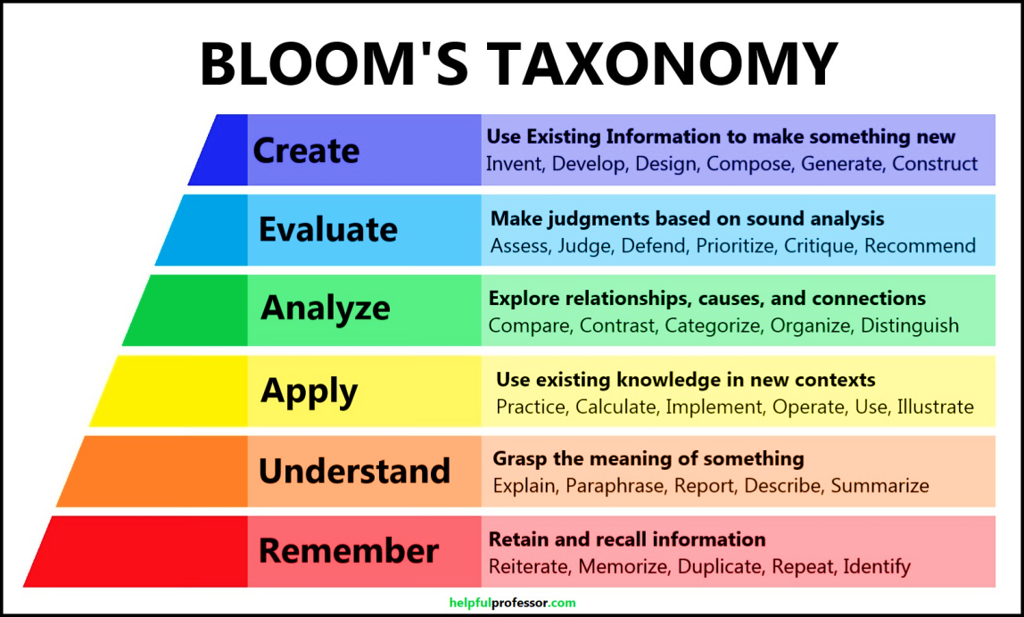

Descriptions of Cognitive Domain (Anderson and Krathwohl’s Taxonomy 2001)
The cognitive domain involves the development of our mental skills and the acquisition of knowledge.
Level | Category | Meaning | Keywords
C1 | Remembering | Recognizing or recalling knowledge from memory. Remembering is when memory is used to produce or retrieve definitions, facts, or lists, or to recite previously learned information. | Define, describe, draw, find, identify, label, list, match, name, quote, recall, recite, tell, write
C2 | Understanding | Constructing meaning from different types of functions be they written or graphic messages or activities like interpreting, exemplifying, classifying, summarizing, inferring, comparing, or explaining. | Classify, compare, exemplify, conclude, demonstrate, discuss, explain, identify, illustrate, interpret, paraphrase, predict, report
C3 | Applying | Carrying out or using a procedure through executing, or implementing. Applying relates to or refers to situations where learned material is used through products like models, presentations, interviews or simulations. | Apply, change, choose, compute, dramatize, implement, interview, prepare, produce, role play, select, show, transfer, use
C4 | Analyzing | Breaking materials or concepts into parts, determining how the parts relate to one another or how they interrelate, or how the parts relate to an overall structure or purpose. Mental actions included in this function are differentiating, organizing, and attributing, as well as being able to distinguish between the components or parts. When one is analyzing, he/she can illustrate this mental function by creating spreadsheets, surveys, charts, or diagrams, or graphic representations. | Analyze, characterize, classify, compare, contrast, debate, deconstruct, deduce, differentiate, discriminate, distinguish, examine, organize, outline, relate, research, separate, structure
C5 | Evaluating | Making judgments based on criteria and standards through checking and critiquing. Critiques, recommendations, and reports are some of the products that can be created to demonstrate the processes of evaluation. | Appraise, argue, assess, choose, conclude, critique, decide, evaluate, judge, justify, predict, prioritize,  prove, rank, rate, select, Monitor
C6 | Creating | Putting elements together to form a coherent or functional whole; reorganizing elements into a new pattern or structure through generating, planning, or producing. Creating requires users to put parts together in a new way, or synthesize parts into something new and different creating a new form or product. This process is the most difficult mental function. | Construct, design, develop, generate, hypothesize, invent, plan, produce, compose, create, make, perform, plan, produce

Graduate Attributes (Program Outcomes) for B.Sc. in Engineering Program based on Washington Accord
Program Outcomes (POs) are narrower statements that describe what students are expected to know and be able to do by the Time of graduation. These relate to the knowledge skills and attitudes that students acquire while progressing through the program. The students of the B.Sc. in CSE program are expected to achieve the following graduate attributes or program outcomes at the time of graduation.
PO1–Engineering knowledge (Cognitive): Apply the knowledge of mathematics, science, engineering fundamentals and an engineering specialization to the solution of complex engineering problems.
PO2–Problem analysis (Cognitive): Identify, formulate, research the literature and analyze complex engineering problems and reach substantiated conclusions using first principles of mathematics, the natural sciences and the engineering sciences.
PO3–Design/development of solutions (Cognitive, Affective): Design solutions for complex engineering problems and design system components or processes that meet the specified needs with appropriate consideration for public health and safety as well as cultural, societal and environmental concerns.
PO4–Investigation (Cognitive, Psychomotor): Conduct investigations of complex problems, considering design of experiments, analysis and interpretation of data and synthesis of information to provide valid conclusions.
PO5–Modern tool usage (Psychomotor, Cognitive): Create, select and apply appropriate techniques, resources and modern engineering and IT tools including prediction and modeling to complex engineering activities with an understanding of the limitations.
PO6–The engineer and society (Affective): Apply reasoning informed by contextual knowledge to assess societal, health, safety, legal and cultural issues and the consequent responsibilities relevant to professional engineering practice.
PO7–Environment and sustainability (Affective, Cognitive): Understand the impact of professional engineering solutions in societal and environmental contexts and demonstrate the knowledge of, and need for sustainable development.
PO8–Ethics (Affective): Apply ethical principles and commit to professional ethics, responsibilities and the norms of the engineering practice.
PO9–Individual work and teamwork (Psychomotor, Affective): Function effectively as an individual and as a member or leader of diverse teams as well as in multidisciplinary settings.
PO10–Communication (Psychomotor, Affective): Communicate effectively about complex engineering activities with the engineering community and with society at large. Be able to comprehend and write effective reports, design documentation, make effective presentations and give and receive clear instructions.
PO11–Project management and finance (Cognitive, Psychomotor): Demonstrate knowledge and understanding of the engineering and management principles and apply these to one’s own work as a member or a leader of a team to manage projects in multidisciplinary environments.
PO12–Life-long learning (Affective, Psychomotor): Recognize the need for and have the preparation and ability to engage in independent, life-long learning in the broadest context of technological change.

Prepared By:  Khan Md. Hasib  Assistant Professor  CSE, BUBT | Checked by: | Approved By:

